# Proposal for Project 2

Alisha, Brandy, Chelsea, and Shaw

## BRIEF ARTICULATION

The website all about woman’s best friend. Ever wanted to know facts about your favorite dog breed? Looking for a new bestie, and want to figure out which one would be best for you? Want to visualize doggie data and identify trends in the data? Or, most importantly, *Jigsaw voice* would you like to play a game? Well, look no further. The “Doggos!” website is for you.

## DATA LINKS & SCREENSHOT METADATA

JS Library: [Lodash](https://lodash.com/)

Database: relational (postgres) ~~dynamodb, for when regular databases aren’t fast enough, and you dont need foreign key constraints!~~ We’re not ready for the future. We like constraints :D

Pull dog information from <https://thedogapi.com/>

Random pictures <https://dog.ceo/dog-api/breeds-list>

Purina dog breeds for “official” pictures (and data?) <https://www.purina.com/dogs/dog-breeds>

Metadata:

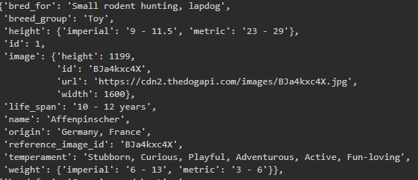

## VISUALIZATION IDEAS

3-4 screenshots

For selecting characteristics

*Starburst*

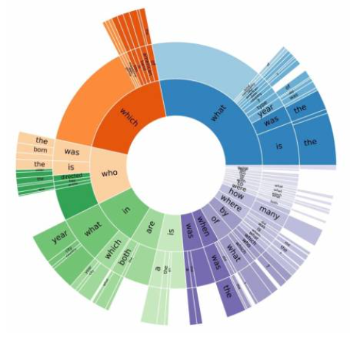

[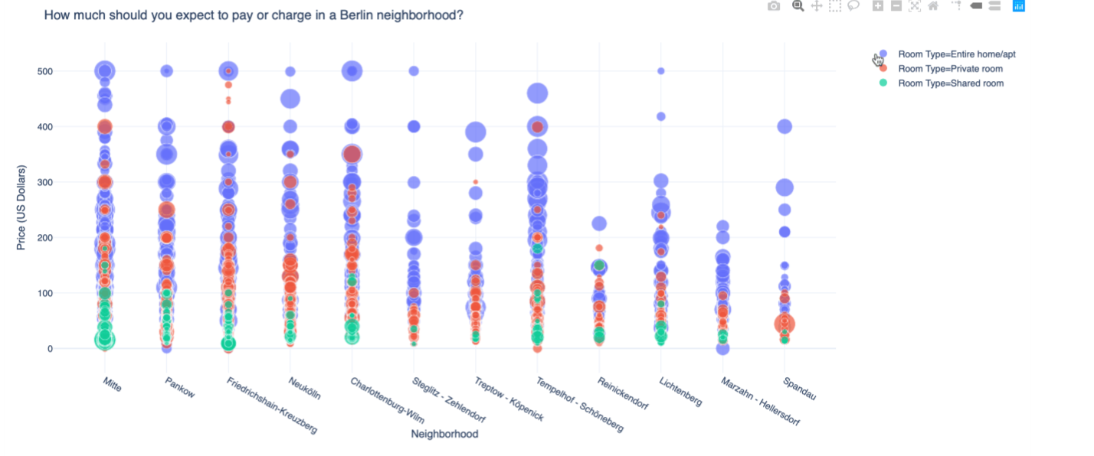](https://towardsdatascience.com/how-to-create-a-plotly-visualization-and-embed-it-on-websites-517c1a78568b)

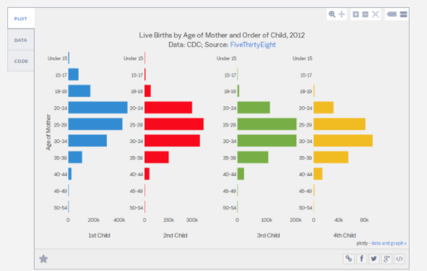

Dog origin countries  
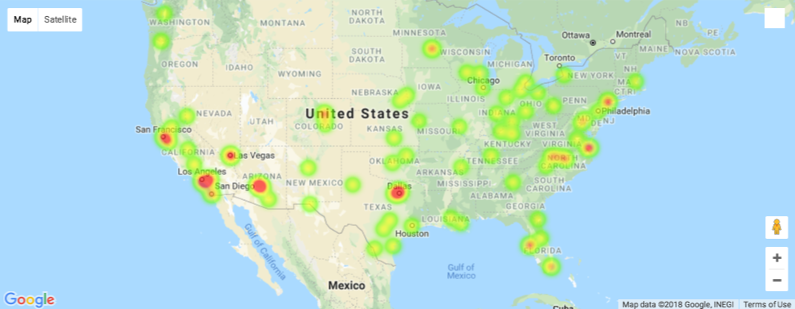

## 

## WEBSITE SKETCH

Stored on github > Project-2/Proposal/website mock up.ppt

<https://github.com/chelseasenter/Project-2/blob/main/Proposal/website%20mock%20up.pptx>

## GITHUB LINK

<https://github.com/chelseasenter/Project-2>